Understanding Practice in Clinical Audit and Registries tool: UPCARE-tool

A protocol to describe the key features of clinical audits and registries

FAQ
Who should complete the tool?
This tool is designed to be completed by individuals and organisations planning and implementing clinical audits and registries. It has been specifically designed for national clinical audits and registries commissioned by the Healthcare Quality Improvement Programme (HQIP; Part of the National Health Service in England) as part of the National Clinical Audit and Patient Outcome Programme (NCAPOP), but can be adapted and used by audits and registries in other settings.

What is the tool for?
The tool is a protocol for audits and registries. It has been designed to provide a “one-stop” summary of the key information about how clinical audits and registries have been designed and carried out. It is expected that this will be published openly for anyone to view, and help users of audit/registry data and audit/registry participants understand the methods, evaluate the quality and robustness of the data, and find information and data that is most relevant to them. For national clinical audits and registries commissioned by HQIP, the intention is that publishing this information openly will reduce the requirement for reporting ad hoc and contract monitoring data and information to HQIP and other national agencies.

What type of information is contained within UPCARE?
It is intended that the responses to the tool are factual and written concisely. Where possible, documents can be embedded and hyperlinks provided if information is published elsewhere. This document is intended to be a complete account of the information for the audit or registry. Please be vigilant about keeping any links included in the document up to date so readers can access full information about the audit or registry.

This tool is not intended to be used to formally “score” the quality of the responses. The design of this tool has been inspired by reporting checklists used for clinical guidelines (e.g. AGREE) and in reporting research studies (e.g. STROBE, SQUIRE).

Who is the intended audience for the tool?
The information contained within the UPCARE tool will enable audit and registry stakeholders to access in one place and in a standard format key information about the audit/registry and evaluate the integrity and robustness of the audit.

Examples of audit/registry stakeholders include:
- Patients / Carers / Public / Patient representative organisations
- Clinicians / Allied health professionals / Healthcare providers / Multi-disciplinary teams / Primary, secondary and tertiary care providers
- National agencies
- Commissioners
- Healthcare regulators

FAQ (cont’d)
How should the responses be written?
Please try and write responses clearly as this will help to make the tool accessible and useful. Some tips and suggestions for writing clearly include:

- avoiding technical jargon where possible
- using short paragraphs and bullet points
- using the “active” voice rather than passive
- keeping sentences short

Where information is published openly elsewhere please provide links and references rather than duplicating information that is already available

When and how often should I complete the tool?
The tool is intended to provide accurate and up to date information about the audit/registry, and so can be updated whenever and however frequently it is relevant to do so. For national clinical audits and registries commissioned by HQIP it is intended that the tool is updated annually, although audits can update the tool more frequently if they wish to.

Each version of the tool should include a date of publication and version number.

Where should the completed UPCARE report be published?
The completed tool should be published online e.g. on the website for the audit or registry.

How was UPCARE designed?
HQIP commission, manage and develop the NCAPOP (National Clinical Audit and Patient Outcomes Programme) under contract from NHS England and devolved nations. The work was led by HQIP who set up a Methodological Advisory Group (MAG) consisting of methodological, statistical and quality improvement experts. Meeting were held on a six monthly basis and the structure and content of the eight quality domains and their key items were agreed by the MAG. The tool was piloted by 5 programmes within the NCAPOP and re-edited in light of comments received. Other comments received by MAG members was also considered as part of the re-editing process. The final version of the UPCARE tool was signed off by the HQIP MAG and will be reviewed annually.

IPR and copyright
© 2018 Healthcare Quality Improvement Partnership Ltd (HQIP)

Contents
Understanding Practice in Clinical Audit and Registries (UPCARE) 1
FAQ 2
Domain 1: Organisational information 6
1.1. The name of the programme 6
1.2. The name of the organisation carrying out the programme 6
1.3. Main website for the programme 6
1.4. Date of publication and version number of the tool on your website 6
Domain 2: Aims and objectives 7
2.1. Overall aim 7
2.2. Quality improvement objectives 7
Domain 3: Governance and programme delivery 8
3.1. Organogram 8
3.2. Organisations involved in delivering the programme 8
3.3. Governance arrangements 9
3.4. Declarations and Conflicts of interest 9
Domain 4: Information security, governance and ethics 10
4.1. The legal basis of the data collection 10
4.2. Information governance and information security 10
Domain 5: Stakeholder engagement 11
5.1. Approaches to involving stakeholders 11
Domain 6: Methods 12
6.1. Data flow diagrams 12
6.2. The population sampled for data collection 12
6.3. Geographical coverage of data collection 13
6.4. Dataset for data collection 13
6.5. Methods of data collection and sources of data 13
6.6. Time period of data collection 15
6.7. Time lag between data collection and feedback 15
6.8. Quality measures included in feedback 16
6.9. Evidence base for quality measures 16
6.10. Case ascertainment 17
6.11. Data analysis 17
6.12. Data linkage 18
6.13. Validation and data quality 18
Domain 7: Outputs 19
7.1. The intended users or audience for the outputs 19
7.2. Editorial independence 19
7.3 The modalities of feedback and outputs 20
7.4 Recommendations 21
7.5 Comparators and benchmarking 22
7.6 Motivating and planning quality improvement 23

Domain 1: Organisational information

The name of the programme
National Gastro Intestinal Cancer Audit Programme (GICAP)

The name of the organisation carrying out the programme
The Clinical Effectiveness Unit at the Royal College of Surgeons of England

Main website for the programme
https://www.nboca.org.uk/
https://www.nogca.org.uk/

Date of publication and version number of the tool on your website
HQIP UPCARE-tool GI Cancer - September 2019 v1.0

Domain 2: Aims and objectives

Overall aim
Note:

A short description of the overall aim(s) of the programme

The National Gastro-Intestinal Cancer Audit Programme (GICAP) comprises both the National Bowel Cancer Audit and the National Oesophago-Gastric Cancer Audit which were previously managed as two separate audits. These national clinical audits evaluate the quality of care and outcomes for patients diagnosed with bowel, oesophageal or gastric cancer in England and Wales.

Quality improvement objectives
Note:

A list or description of the key quality improvement (QI) objectives of the programme.

A brief rationale for how the QI objectives were chosen. Please take into consideration evidence to support the QI objectives, including the COMET (Core Outcome Measures in Effectiveness Trials) initiative.

Information produced by the Audit is used by NHS Trusts to assess their care against national standards/clinical guidance and the performance of other trusts. For example, the Audit outputs show whether trusts are following national recommendations such as those published by NICE and whether there is any variation in the provision of care. Risk-adjusted outcomes such as 90-day post-operative mortality enable the identification of potential outlier trusts, which are notified of their outlier status and will investigate the causes (these may be related to data quality issues or clinical practice). In cases where clinical practice is identified as contributing to poorer outcomes, trusts’ review and improvement of practices can have a direct impact on patient care.

Trust and individual consultant level Clinical Outcomes Programme measures have been selected with the involvement of relevant professional bodies to enable evaluation of surgical care and support improvements in outcomes. These measures are publicly available, providing transparency and supporting patient choice.

Domain 3: Governance and programme delivery

Organogram
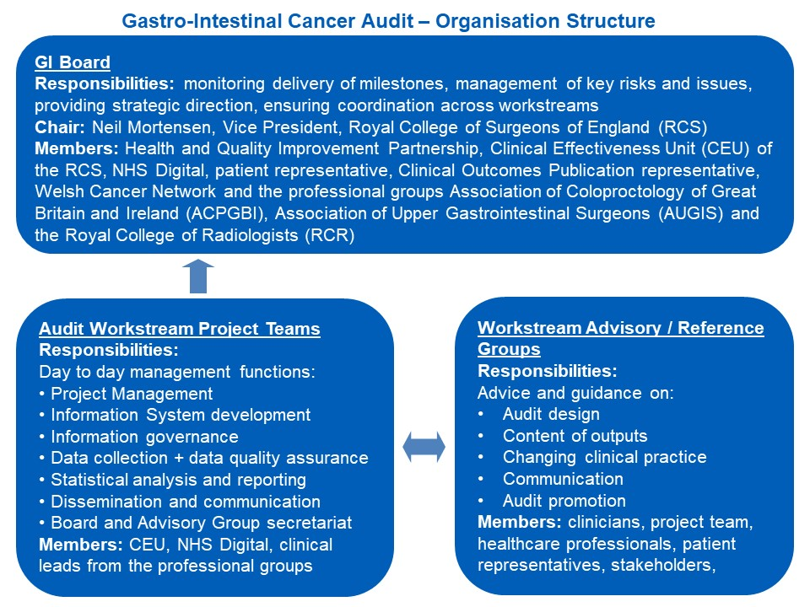

Organisations involved in delivering the programme
Note:

A list of organisations with a formal role in delivering the programme. This includes organisations which:
- Are contracted to carry out elements of the programme
- Have a formal role in governing or steering the programme

For each organisation list:
- Name
- Website URL if available
- A description of its role in the programme

Clinical Effectiveness Unit at the Royal College of Surgeons - https://www.rcseng.ac.uk/standards-and-research/research/clinical-effectiveness-unit/
Contracted by HQIP to run GICAP; Provides the statistical methodology and the analysis presented in the annual report and associated short reports/ journal papers as well as a clinical fellow to provide day to day clinical input.

NHS Digital -
Subcontracted by the RCS to provide day to day project management for the audit, management of user enquiries, communications with users and provision of the data collection platform for the GICAP data to be submitted by Providers.
www.digital.nhs.uk

Members from the professional bodies listed below assist with identifying the quality metrics for the audit, the clinical interpretation of the data presented in the annual report and in disseminating communications to clinical teams in Provider organisations.

The Association of Coloproctology of Great Britain and Ireland (ACPGBI) –
www.acpgbi.org.uk/

Association of Upper Gastro Intestinal Surgeons (AUGIS)
www.augis.org.uk

British Society of Gastroenterologists (BSG)
https://www.bsg.org.uk/

Royal College of Radiologists
https://www.rcr.ac.uk/

The Healthcare Quality Improvement Partnership (HQIP) - https://www.hqip.org.uk/
Commissions the NCAPOP programme of which GICAP is a part.

Governance arrangements
Note:

Governance of the project should include representatives from all key stakeholders. Please describe the governance arrangements including:
- A list of individuals within each governance group described in the organogram (or the URL of where this information is available on the programme website)
- The process used for sign-off indicating that the audit or registry data/feedback/reports have been quality assured and are ready for release
- If available, the URL to publicly published meeting/Board minutes (e.g. by a board or steering group)

The audit is governed by a Project Board; the first meeting is scheduled for September 2018. The board will meet twice a year and will be chaired by an RCS Council Member. Representatives of the Board are comprised of members from the RCS, ACPGBI, AUGIS, RCR, NHS Digital, patient representatives and HQIP.

The Clinical Advisory Groups are chaired by a representative from ACPGBI (NBOCA) or AUGIS (NOGCA), who sit on the Project Board. These groups include members from RCS, ACPGBI, AUGIS, NHS Digital, patient and charity representatives, clinical nurse specialist, palliative care and pathology service representatives. The NBOCA group also has a representative from the National Cancer Registration and Analysis Service. The groups each meet twice per year to review the methodology and findings in the annual reports and short reports and advise on the clinical focus of the audit, dissemination of findings, and collaboration with relevant partners.

Each of the Project Teams meets monthly to manage routine matters relating to the project.

The organogram contains details of the members of the 3 groups outlined above.

Declarations and Conflicts of interest
Note:

Evidence that declarations and conflicts of interest have been considered, declared and where appropriate, mitigated appropriately:
- DOI / COI process and policy outlining how DOI and potential conflicts of interest are identified and managed
- A web URL to the publicly published DOI/COI register for all individuals involved in the programme and where appropriate, information about how these have been mitigated

Members of the GICAP Project Board will be asked to declare any conflicts of interest when the board is convened.

Domain 4: Information security, governance and ethics

The legal basis of the data collection
Note:

A description of the legal basis for the data collection, specific to each country where the data are collected. Examples include:
- Informed consent
- Section 251 (NHS Health and Social Care Act 2006) approval
- Other types of patient controlled data permission
- Confidentiality Advisory Group approval for data collection
- Data sharing agreements e.g. Public Health England

This could include links to:
- Consent forms
- Information provided to patients about participation and usage of data
- Further information about how patients can control the use of their data
- Information about ethical committee review

The audit has approval under section 251 of the NHS Health and Social Care Act 2006 to collect identifiable data without consent in England and Wales. Patients can opt out of data collection by contacting their local clinical team or notifying the audit directly via the NHS Digital Contact Centre.
The Patient Information Leaflets describe the data usage and linkages in addition to how to opt out. They are available at:
https://www.nboca.org.uk/resources/patient-information-leaflet/

https://www.nogca.org.uk/resources/patient-leaflet/

Information governance and information security
Note:

Include:
- The Information Governance Toolkit score and URL to the organisation’s Information Governance Toolkit Assessment Report
- If the IG toolkit score is less than satisfactory, indicate how the organisation is improving its security processes to achieve a satisfactory score and when the programme will be re-assessed
- Details of any other information governance and security accreditations achieved by the registry (e.g. ISO 27001)

IG Toolkit score: Royal College of Surgeons in England
IGT Organisation code: 8HM21
Current percentage score: 75% Satisfactory
IG Toolkit version: V14.1 2017-18

IG Toolkit score: NHS Digital
IGT Organisation code: X26
Current percentage score: 90% Satisfactory
IG Toolkit version: V14.1 2017-18

View the IG Toolkit Assessment Reports for the Royal College of Surgeons and NHS Digital by visiting the IG Toolkit.

Search under Reports and enter the organisation name under ‘Look for’: https://www.igt.hscic.gov.uk

Domain 5: Stakeholder engagement

Approaches to involving stakeholders
Note:

A description of how stakeholders are involved in designing and carrying out the programme

Examples of types of involvement that might be listed here include:

- Designing the programme
- Selecting quality metrics
- Defining aims and objectives
- Setting priorities
- Collecting data
- Contributing to data analysis and interpretation
- Governance
- Disseminating feedback and communications

The main stakeholders are:
- Patients and carers
- Clinical teams in surgical and medical oncology
- Managers
- Commissioners
- Professional groups such as the ACPGBI and AUGIS
- Bowel cancer charities
- Provider organisations
- NHS Digital

All of the stakeholders listed in 3.1 are represented on the Project Board and Clinical Advisory Group.

Clinical input is received across all of the GI Cancer audit activities, particularly providing expertise on matters relating to selecting quality metrics, defining data items, contributing to analysis and interpretation. They have a key role in disseminating feedback and communications to clinicians in provider organisations.
Our patient and charity representatives, including the Oesophageal Patients Association and Beating Bowel Cancer, are particularly involved in our communications e.g. the patient information leaflets and the annual reports
NHS Digital are subcontracted by the RCS to provide day to day project management for the audit, management of user enquiries, communications with users and provision of the data collection platform for the NBOCA data to be submitted by Providers.

Domain 6: Methods

Data flow diagrams
Note:
A data flow diagram showing each data flow into and out of the audit/registry. The diagram should indicate:
- What organisations are flowing data in/out of the programme
- What data items are within each data flow in/out of the programme
- The legal basis for each data flow, e.g. section 251, consent

GI Cancer data flows diagram
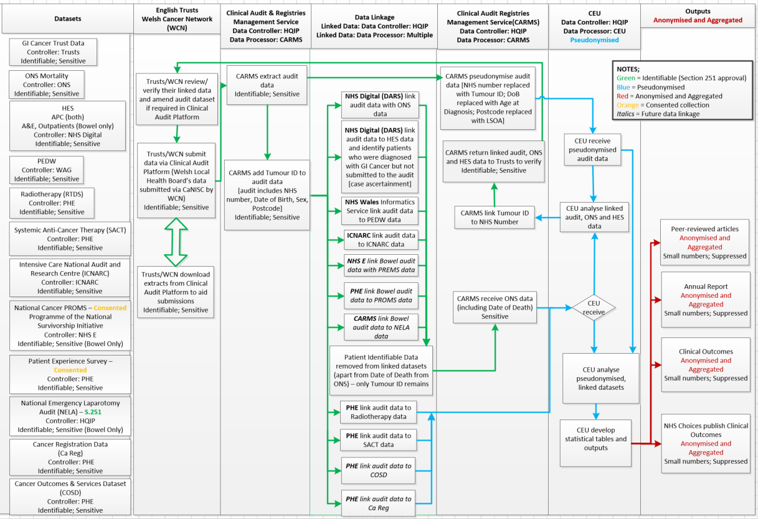

The population sampled for data collection
Note:

A description of the patient population or sampling frame for data collection. This might include:
- Details of inclusion and exclusion criteria
- Standard nomenclature to define patient populations (e.g. ICD codes, SNOMED terms)

The bowel cancer audit stream includes all first diagnoses of primary bowel cancer within the current reporting period. Included patients must be:
• Aged 18 or older at the date of diagnosis
• Diagnosed in the audit period (April-March)
• Diagnosed with colorectal cancer, with one of the following ICD10 codes:
• C18 Malignant neoplasm of colon
• C19 Malignant neoplasm of rectosigmoid junction
• C20 Malignant neoplasm of rectum

The following are excluded: Sarcomas, B cell lymphoma, Neuroendocrine / Carcinoid tumours, melanoma

The OG cancer audit stream includes patients diagnosed in England and Wales with invasive epithelial cancer of the oesophagus or stomach (ICD10 codes C15 and C16), or oesophageal high grade dysplasia.

The following are excluded:
- Patients who are diagnosed with OG cancer abroad
- Patients without a confirmed histology of OG cancer
- Patients who die before MDT discussion
- Gastro-intestinal stromal tumours (GISTs)
- Neuroendocrine tumours
- Sarcomas (these very rare cancers originate from connective tissue and often behave differently from epithelial cancers)
- Recurrences of cancer

Geographical coverage of data collection
Note:

A description of the geographical coverage of the data collection. Include details of both:
- geographical areas eligible for inclusion
- geographical areas that actually participated in data collection

This could include:
- A text description of coverage
- An illustration or map to visualise the coverage
- Summary data
- Links to data files containing geographical identifiers
Data is collected from trusts/health boards in England and Wales. All eligible trusts/hospital sites in England and Health Boards in Wales submit data to the audit for inclusion in the annual report.

Dataset for data collection
Note:

A list (or web URL to online documentation such as a data dictionary) of the items included in the data collection

State how the dataset chosen aligns with the QI objectives and COMET Core Outcome Sets (COS) as described in section 2.2.

The core datasets for data collection are published here: https://www.nboca.org.uk/resources/nboca-dataset-2018-2019/

https://www.nogca.org.uk/resources/nogca-dataset/

Methods of data collection and sources of data
Note:

A description (or web URL to online documentation) of how the data were collected and the sources of data.

Examples include:
- Online, e.g. webtool or portal
- Retrospective case record review
- Linkage to existing data sources
- Extracts of administrative data
- Surveys
- Extractions from electronic health records

Clinical data are submitted to the Clinical Audit Platform, which is a secure online web tool designed and hosted by NHS Digital specifically to collect audit data.

The audit data is linked to other mandated national data sets including:
- Radiotherapy (RTDS)
- Chemotherapy (SACT)
- Hospital Episode Statistics (HES) and the Patient Episode Database for Wales (PEDW)
- Office for National Statistics (ONS) civil registration data
- Cancer Registration data and COSD for England

Work is also being undertaken to assess feasibility of linkage of the bowel cancer audit data to Patient Experience data and the other audit sources including the Intensive Care National Audit Dataset (ICNARC) and National Emergency Laparotomy Audit (NELA).

Time period of data collection
Note:

The time period for data collection, using a start date (DD/MM/YYYY) and end date as applicable. For a continuous prospective data collection then this may only be a start date.

Data collection is continuous.

The annual reports for the bowel and OG cancer audits cover one and two years, respectively. For example, bowel cancer audit Annual Report 2018 covers patients diagnosed between 01/04/2016 and 31/03/2017 the OG cancer audit Annual Report 2018 covers patients diagnosed between 01/04/2015 and 31/03/2017.

Time lag between data collection and feedback
Note:

A description of the time lag between data collection and feedback to participants in the programme – try and be as specific as possible

If ‘real time’ please describe exactly what this means, e.g. monthly, daily, minute-by-minute

This could also include details about time intervals for the various steps between data collection and feedback/publication such as waiting for linked data to be supplied or for sign off.

This year the annual reports publish data which are between 18 -20 months old from the last diagnosis. The NOGCA 2018 annual report was published in September 2018 and reported on patients diagnosed up to 31/03/17. The NBOCA 2018 report is due to be published by the end of 2018 subject to sign off by NHS England, and will report on diagnoses up to 31/03/17.

The first data collection deadline for NHS organisations to submit data is in late October or early November following the end of the financial year. The second and final submission deadline is expected to be in February following linkage of the audit records to HES and ONS data and allowing trusts time to update records following the data quality review.

Feedback is provided to trusts between the two deadlines to facilitate data quality review, for example at this point the bowel audit data has been linked to HES/PEDW for case ascertainment checks and also to ONS deaths data. This feedback period allows trusts to review their data completeness (e.g. for staging information) and to review their data if they are flagged as a possible outlier in the clinical outcomes programme metrics.

Quality measures included in feedback
Note:

A list (or web URL to online documentation) of the quality measures reported by the programme

Provide a mapping to classify these as:
- Process metrics
- Outcome metrics
- Organisational/structure metrics

Please state what metrics are provided at trust level and how often this trust level information is made available, e.g. quarterly, 6-monthly. If ‘real time’ please describe exactly what this means, e.g. monthly, daily.

The outcome measures reported by the audits include:
- 90-day post-operative mortality
- 30-day unplanned readmission
- Length of stay

See the trust results sections on the websites for the complete list https://www.nboca.org.uk/trust-results/
https://www.nogca.org.uk/trust-results/

Evidence base for quality measures
Note:

A list or description of the sources of evidence used to define the quality metrics. Examples include:
- Clinical guidance (e.g. NICE guidance)
- Clinical standards
- Systematic reviews
- Professional society recommendations
- Policy documents
- Clinical trials

- Association of Coloproctology of Great Britain & Ireland (ACPGBI): Guidelines for the Management of Cancer of the Colon, Rectum and Anus (2017)
- NICE: Colorectal cancer diagnosis and management. [CG131] (2011, updated 2014)
- NICE: Improving outcomes in colorectal cancers (2004)
- NICE: Improving supportive and palliative care for adults with cancer. [CSG4] (2004)
- NICE: Laparoscopic surgery for colorectal cancer (TA105) (2006)
- NHS Commissioning Cancer Services. Department of Health. (2011)
- NHS Outcomes Framework, Department of Health 2017
- Delivering the Cancer Reform Strategy. Department of Health. (2010)
- BSG / Fitzgerald RC, di Pietro M, Ragunath K, et al. British Society of Gastroenterology guidelines on the diagnosis and management of Barrett's oesophagus. Gut. 2014; 63(1): 7–42.
- Allum W, Blazeby J, Griffin S, et al. Guidelines for the management of oesophageal and gastric cancer. GUT 2011; 60(11): 1449–72.
- NICE. Oesophago-gastric cancer: assessment and management in adults: NICE guideline NG83. London: NICE, 2018.
- NICE. Barrett’s Oesophagus: ablative therapy: NICE clinical guideline CG106. London: NICE, 2010.

Case ascertainment
Note:

Describe the level of case ascertainment achieved. Include links or detail for additional information about methodology

In the bowel cancer audit case ascertainment is >90% for the 2016-17 audit year.

In the OG cancer audit case ascertainment is around 80%.

Data analysis
A supplementary file is available for NBOCA which explains the methodology used in the annual reports. This includes methods for missing data, case-mix adjustment and the potential bias from type 2 opt out: www.nboca.org.uk/reports/methodology-supplement/

FAQs also provide information on methods: https://www.nboca.org.uk/about/faq/

Annex 2 of the OG cancer audit’s Annual Report 2018 describes the audit’s methods.
https://www.nogca.org.uk/reports/2018-annual-report/

Data linkage
Note:

A description of any data linkage carried out as part of the audit or registry. Include details of:
- Data sources
- Methods of linkage
- Evaluation of the quality of data linkage

If no data linkage carried out, state “No linkage performed”
This could include details about the impact of patient opt outs where these apply, e.g. the proportion of patients before and after opt outs are applied; changes in key characteristics of patient group following opt out such as gender, ethnicity

The audit data is linked to other mandated national data sets including:
- Radiotherapy (RTDS)
- Chemotherapy (SACT)
- Hospital Episode Statistics (HES) and the Patient Episode Database for Wales (PEDW)
- Office for National Statistics (ONS) civil registration data
- Cancer Registration data and COSD for England

Data are linked using deterministic linkage on NHS number, date of birth, sex and postcode. The characteristics of linked and unlinked records are compared to assess the potential for bias, and the overall linkage rate is published in the annual report. Incomplete linkage due to type 2 opt-out is a larger issue than incomplete linkage due to errors / missing values in the linkage identifiers.

Work is also being undertaken to assess feasibility of linkage of the NBOCA data to Patient Experience data and the other audit sources including the Intensive Care National Audit Dataset (ICNARC) and National Emergency Laparotomy Audit (NELA).

Validation and data quality
Note:

A description of how data quality and analyses have been validated. Examples of validation include:

- Piloting and refining data collection methods and dataset changes
- Building in validation processes at the point of data entry
- Validation by clinical teams
- Data cleaning
- Statistical analyses of data quality (e.g. missing data)
- Validation of statistical models and algorithms
- Quality assurance and unit testing of analytical code

Data validation rules are implemented in the data collection platform and cleaning is carried out by analysts. Clinicians have access to their own data for checking but cannot edit their data. This is to minimise “gaming” of data.

After the first data submission deadline initial results are returned to trusts and consultants for checking. They can then amend and complete missing information but they cannot add new cases because data have already been linked to other datasets, most importantly to ONS mortality and HES/PEDW.

Data quality measures (data completeness of key data items and case ascertainment) are reported at trust level alongside performance indicators. Within the Bowel cancer audit analysis, the only subjective measure used in risk adjustment is ASA grade. Trusts are instructed that this should come from the anaesthetist’s judgement and not from surgeons. The distribution of ASA grades is reported at each trust. The OG cancer audit additionally adjusts for comorbidity and performance status data submitted by hospitals.

The risk-adjustment models for postoperative mortality in both audit streams have been developed using appropriate statistical methods and have been published in a peer-reviewed publication.

Analyses in the report are carried out by experienced statisticians / epidemiologists with supervision from senior statisticians. The descriptive analyses are quality assured by being checked by analysts at NHS Digital.

The NBOCA organisational survey was piloted before being rolled out nationally.

Domain 7: Outputs

The intended users or audience for the outputs
Note:

A list or description of the intended users or audience of feedback data produced by the programme. Examples include:

- Clinical commissioning groups or Health Boards
- Specialist commissioners
- Trust/hospital boards
- Clinical teams
- Individual clinicians
- General public
- Patients
- Carers
- Policy makers
- Politicians
- Media
- National agencies

The audit designs feedback for:
- Patients with bowel and OG cancer, their carers and charitable groups
- Commissioner organisations
- Trust boards and clinical teams
- Policy makers
- Quality assurance initiatives e.g. CQC, NCAB
- Quality improvement initiatives e.g. Getting It Right First Time
- General public

Editorial independence
Note.

A statement about the independence of the programme in regards to the content, e.g. findings, recommendations.

The contents of the outputs are independently produced the RCS CEU and quality assured by the Board through the governance processes described in previous section. However, NHS England and NHS Wales retain a right of review as funding organisations.

The modalities of feedback and outputs
Note:

A description of how data are fed back to participants of the programme

Please also describe how outputs are agreed, i.e. the quality assurance process within the programme such as Board sign off.

The audit provides feedback for the following types of participant
- The Annual Report is used by Clinicians, Providers and Commissioners; this contains data tables, graphs, trust-level results, interpretations and recommendations.
- A “patient friendly” report is produced which is aimed at patients and their carers. It is a simpler to read document with infographics, clear explanations of clinical terms and references.
- Two short reports per year are published on focussed clinical topics or methodological developments.
- Peer-reviewed publications are published from the audit.
- Audit project team members present findings at national and international conferences
- Trust-level PDFs are produced which are sent to each individual trust with their own results on. These are also provided in presentation format so that they can easily be reviewed and discussed by Multi-Disciplinary Teams. These trust level reports are also made publicly available via the website so any interested party can access them. The presentations contain templates for local action plans
- An interactive website allows comparison of trust results to those locally and nationally.
- The NBOCA has a twitter feed to improve its online presence, make announcements and publicise findings.
- Metrics used by national organisations such as CQC in their reviews of Providers, NCAB, and GIRFT
- Audit results are used for NHS medical revalidation of the General Medical Council.
- Audit results are presented on Data.gov.uk.
- Information for patients is published on NHS Choices and on the NBOCA website

Recommendations
Note:

The programme, in making specific recommendations about how to improve the quality or safety of healthcare services should provide a web URL to any documents making recommendations to participants

As a general principal, recommendations should:
- be specific, action oriented, and tailored to the intended audience
- agreed and signed off through an agreed process
- reviewed (e.g. annually)
- be underpinned by evidence and be supported by data collected by the programme
- be designed to have impact

The annual report publishes key findings and makes recommendations on the quality of care received by patients.

The audit produces local reports for each trust to enable them to review their performance. This includes provision of a slide pack for use by MDTs to review their performance in comparison to regional and national performance and a template for local action plans.

The clinical leads and the ACPGBI, AUGIS and RCR members on the Project Board engage with their colleagues in trusts to discuss how trusts can action the recommendations.

Potential outliers are followed up according to HQIP’s “Detection and management of outliers” policy. The outlier management policies are available on the audit stream websites.

Publication of data via the Clinical Outcomes Publication makes individual surgeon level
performance data available via NHS Choices/ My NHS. The audit has an outlier policy for COP. As well as potentially outlying consultants being notified in writing, the audit’s clinical lead, representing the professional body, communicates directly with them.

Comparators and benchmarking
Note:

A description or list of if/how performance is compared between healthcare providers or areas, and the benchmark against which performance is measured.

This should provide a high level overview of how comparisons are made using the programme data, not a detailed list of all indicators and how they are individually used to benchmark or compare performance.

Examples of benchmarks include:
- National
- International
- Regional
- Organisational
- Clinical team
- Individual clinician
- Audit/registry standards
- Relative benchmarks (e.g. top 10%)
- Temporal (e.g. changes over time)
- Results from randomised controlled trials

The annual report provides comparative performance data for trusts. Each trust’s performance is benchmarked against overall average for England and Wales. In addition, comparisons are available with
- The average for its Cancer Alliance
- Neighbouring trust results

Data quality measures (case ascertainment and data completeness) are Red-Amber-Green rated against aspirational targets.

The Clinical Outcomes Publication provides comparative performance data for individual consultants and for trusts, benchmarked against overall average for England. Comparisons are available with other consultants and other trusts in England.

For a description of each NBOCA performance indicator and its mapping to national guidelines see https://www.nboca.org.uk/resources/performance-indicators-description/

For a description of NOGCA indicators, see: https://www.nogca.org.uk/trust-results/explanatory-notes/

Motivating and planning quality improvement
Note:

A short description of the approaches the programme uses to motivate and support quality improvement.

Programmes are not expected to provide a bespoke service to support trusts to interpret the findings or recommendations. The programme should, however, provide information in a format that is easy to digest and ready to use for the intended audience.

Examples of approaches include:
- Recommendations for action
- Action plans
- Education and training
- Supporting peer learning
- Providing positive feedback
- Workshops
- Including motivating statements as part of feedback

The annual report publishes key findings and makes recommendations on the quality of care received by patients.

The audit produces local reports for each trust to enable them to review their performance. This includes provision of a slide pack for use by MDTs to review their performance in comparison to regional and national performance and a template for local action plans.

The clinical leads and the ACPGBI members on the Project Board engage with their colleagues in trusts to discuss how trusts can action the recommendations.

Publication of data via the Clinical Outcomes Publication makes individual surgeon level performance data available via NHS Choices/ My NHS. The audit has an outlier policy for COP. As well as potentially outlying consultants being notified in writing the audit’s clinical lead, representing the professional body, communicates directly with them.

AGREE stands for the Appraisal of Guidelines for Research & Evaluation. See https://www.agreetrust.org/about-the-agree-enterprise/introduction-to-agree-ii/, last accessed 24 April 2018.
STROBE stands for Strengthening the Reporting of Observational Studies in Epidemiology. See https://www.strobe-statement.org/index.php?id=strobe-home, last accessed 24 April 2018.
SQUIRE stands for Standards for Quality Improvement Reporting Excellence. See http://www.squire-statement.org/, last accessed 24 April 2018.
The COMET initiative, established through funding from the Medical Research Council (MRC) North West Hub for Trials Methodology brings together people who are interested in developing and applying agreed standardised sets of outcomes known as core outcome sets (COS). The COMET website states that ‘These [COS] sets should represent the minimum that should be measured and reported in all clinical trials, audits of practice or other forms of research for a specific condition.’ (http://www.comet-initiative.org/about/overview, accessed 24 April 2018).COMET has an online database of projects, trials, research etc., which can be searched to identify COS in a particular health area or population. The use of COMET and COS is endorsed by organisations such as the Health Research Authority (HRA), the National Institute for Health Research (NIHR), Cochrane Collaboration and other national and international organisations. See http://www.comet-initiative.org/ for full information (last accessed 24 April 2018)

